 | 7.1.14 Editors - 3D Viewport - Header - Mesh - Sculpt mode - Sculpt menu
Table of content
Sculpt Mode - Sculpt Menu 4
Legacy submenu 4
Move 4
Snapping 5
Precision movement 5
Header Values 5
Numerical Input 5
Limit Axis 5
Orientation 5
Last Operator Move 6
Move X, Y Z 6
Orientation 6
Proportional editing 6
Proportional Falloff 6
Proportional Size 6
Connected 6
Projected(2D) 6
Rotate 6
Snapping 6
Precision rotation 7
Header Values 7
Numerical Input 7
Limit Axis 7
Last Operator Rotate 7
Angle 7
Axis 7
Orientation 7
Mirror Editing 7
Proportional editing 7
Proportional Falloff 8
Proportional Size 8
Connected 8
Projected(2D) 8
Scale 8
Snapping 8
Precision Scale 8
Header Values 8
Numerical Input 8
Limit Axis 8
Last Operator Resize 9
Angle 9
Axis 9
Orientation 9
Mirror Editing 9
Proportional editing 9
Proportional Falloff 9
Proportional Size 9
Connected 9
Projected(2D) 9
Box Hide 9
Box Show 9
Lasso Hide 10
Lasso Show 10
Line Hide 10
Line Show 10
Polyline Hide 10
Polyline Show 10
Box Trim 10
Lasso Trim 10
Line Trim 10
Line Project 11
Transform submenu 11
Sphere 11
Last operator Filter Mesh 11
Strength 11
Repeat 11
Orientation 11
Axis 11
Fair Positions 11
Fair Tangency 11
Last Operator Edit Face Sets 11
Mode 12
Strength 12
Modify Hidden 12
Box Add 12
Lasso Add 12
Smooth 12
Surface Smooth 12
Inflate 12
Relax Topology 12
Relax Face Sets 12
Sharpen 12
Enhance Details 12
Erase Multires Displacement 13
Randomize 13
Last operator Filter Mesh 13
Strength 13
Repeat 13
Orientation 13
Axis 13
Subdivide submenu 13
Last Operator Subdivision Set 14
Level 14
Relative 14
Sample Color 14
Set Vertex Color 14
Last operator Fill 14
Strength 14
Fill Color 14
Set Pivot 14
Last operator Set Pivot Position 14
Mode 14
Show / Hide submenu 15
Toggle Visibility 15
Last operator Face Sets Visibility 15
Mode 15
Hide active Face Sets 15
Last operator Face Sets Visibility 15
Mode 15
Show All 15
Invert Visible 15
Last operator Face Sets Visibility 15
Mode 15
Hide Masked 15
Rebuild BVH 15
Transfer Sculpt Mode 15

Sculpt Mode - Sculpt Menu

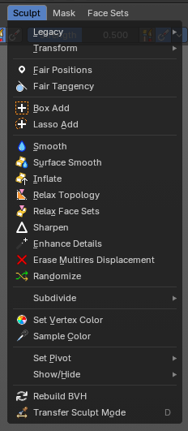
This group of operators contain act-once operators to assist in every day sculpting workflows.

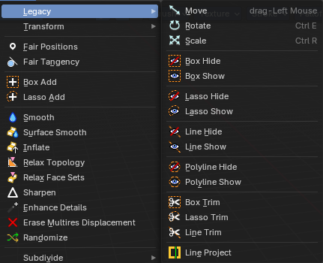
Legacy submenu
The legacy menu contains operators from the old act-once tool system that already exists in the tool shelf that use the new mode based tool system.

Move
Activates the old move tool. The old move tool does not show a widget!
Note that the hotkey for this tool is not displayed correctly. But can't be fixed by us. The hotkey is ctrl W

Snapping
Holding down Ctrl activates temporary global snapping.

Precision movement
When you hold down shift, then you will have a much slower but also much preciser movement.

Header Values
When you move your object then you will see some values in the header, which defines the current position of the object.
The value m stands for the default metric system. Meters. You can change the units in the Properties editor in the Scene properties in the Units panel. When you choose kilometers here then you will see a km instead m.
The value D stands for the distance of the current selected axis. This can also be two axis. Then you have two d values. The value in the brackets is then the direct distance to the starting point.
These values are always relative to the starting point. You always start with zero, regardless of the real world position.

Numerical Input
When you move the object, and hold down the mouse and type in a value, like 20, then the movement will be performed by the value that you have typed in. In this case by 20 units in direction of the selected axis.

Limit Axis
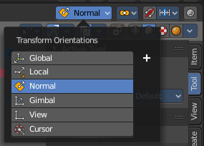
When you want to rotate a specific axis, then press X or Y or Z to limit the rotation to this axis. You usually start in global orientation. But you can change this in the Orientation settings.
By holding down the mouse button and pressing the X, Y or Z key twice you can toggle this to local. But also to other orientations. This depends in what orientation you start. With normal you can toggle that way between Normal and global.
This can be combined with the numerical input. Type in X, type in X again to use the local space, type in 20 to move by 20 units in local orientation. Release the mouse to confirm.


Orientation
The widget can have different orientations. The menu items should be self explaining.

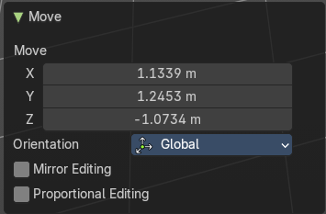
Last Operator Move

Move X, Y Z
The position. Attention, the actual world orientation and rotation does not matter here. It always starts with a value of zero, and moves relative to this zero then. For the actual location values have a look in the sidebar in the transform panel.

Orientation
The widget can have different orientations. The menu items should be self explaining.

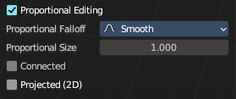
Proportional editing
Enables proportional editing. Activating proportional editing reveals further settings.

Proportional Falloff
Adjust the falloff methods.

Proportional Size
See and adjust the falloff radius.

Connected
The proportional falloff gets calculated for connected parts only.

Projected(2D)
The proportional falloff gets calculated in the screen space. Depth doesn't play a role. When it's in the radius, then it gets calculated.

Rotate
Activates the old Rotate tool. This tool has no widget!

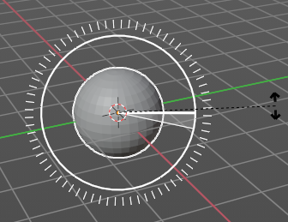
Snapping
Holding down Ctrl activates temporary global snapping. It snaps then by 5 degrees steps.
When you use the white circle to rotate, then the widget also shows a division circle around the widget. This divisions shows even finer when you do precision rotation.

Precision rotation
When you hold down shift, then you will have a much slower but also much preciser rotation.

Header Values
When you rotate your object then you will see some values in the header, which defines the current rotation of the object. The rotation is shown in degrees.

Numerical Input
When you rotate the object, and hold down the mouse and type in a value, like 20, then the rotation will be performed by the value that you have typed in. In this case by 20 degree around the selected axis.

Limit Axis
When you want to rotate a specific axis, then press X or Y or Z to limit the rotation to this axis. You usually start in global orientation. But you can change this in the Orientation settings.
By holding down the mouse button and pressing the X, Y or Z key twice you can toggle this to local. But also to other orientations. This depends in what orientation you start. With normal you can toggle that way between Normal and Global.
This can be combined with the numerical input. Type in X, type in X again to use the local space, type in 20 to rotate by 20 degree. Release the mouse to confirm.

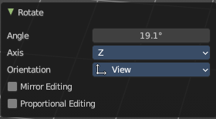
Last Operator Rotate

Angle
The rotation. Attention, the actual world orientation and rotation does not matter here. It always starts with a value of zero, and rotates relative to this zero then. For the actual rotation values have a look in the sidebar in the transform panel.

Axis
Which axis to rotate.

Orientation
The widget can have different orientations. The menu items should be self explaining.

Mirror Editing
Enable mirror editing.

Proportional editing
Enables proportional editing. Activating proportional editing reveals further settings.

Proportional Falloff
Adjust the falloff methods.

Proportional Size
See and adjust the falloff radius.

Connected
The proportional falloff gets calculated for connected parts only.

Projected(2D)
The proportional falloff gets calculated in the screen space. Depth doesn't play a role. When it's in the radius, then it gets calculated.

Scale
Activates the old Scale tool. This tool has no widget!

Snapping
Holding down Ctrl activates temporary global snapping.

Precision Scale
When you hold down shift, then you will have a much slower but also much preciser scale.

Header Values
When you scale your object then you will see some values in the header, which defines the current scale of the object.
These values are always relative to the starting point. You always start with 1, regardless of the real world scale.

Numerical Input
When you scale the object, and hold down the mouse and type in a value, like 20, then the scale will be performed by the value that you have typed in. In this case by factor 20 along the selected axis.

Limit Axis
When you want to rotate a specific axis, then press X or Y or Z to limit the scale to this axis. You usually start in global orientation. But you can change this in the Orientation settings.
By holding down the mouse button and pressing the X, Y or Z key twice you can toggle this to local. But also to other orientations. This depends in what orientation you start. With normal you can toggle that way between Normal and Global.
This can be combined with the numerical input. Hold down mouse, type in X, type in X again to use the local space, type in 20 to scale by 20 units. Release the mouse to confirm.

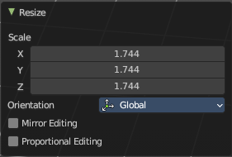
Last Operator Resize

Angle
The rotation. Attention, the actual world orientation and rotation does not matter here. It always starts with a value of zero, and rotates relative to this zero then. For the actual rotation values have a look in the sidebar in the transform panel.

Axis
Which axis to rotate.

Orientation
The widget can have different orientations. The menu items should be self explaining.

Mirror Editing
Enable mirror editing.

Proportional editing
Enables proportional editing. Activating proportional editing reveals further settings

Proportional Falloff
Adjust the falloff methods.

Proportional Size
See and adjust the falloff radius.

Connected
The proportional falloff gets calculated for connected parts only.

Projected(2D)
The proportional falloff gets calculated in the screen space. Depth doesn't play a role. When it's in the radius, then it gets calculated.

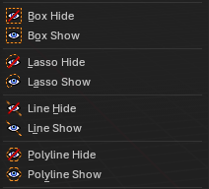
Box Hide
Calls a rectangle tool that allows you to hide away mesh parts.

Box Show
Calls a rectangle tool that allows you to reveal hidden mesh parts.

Lasso Hide
Calls a lasso tool that allows you to hide away mesh parts.

Lasso Show
Calls a lasso tool that allows you to reveal hidden mesh parts.

Line Hide
Calls a line tool which hides the vertices at the one side away.

Line Show
Calls a line tool that allows you to reveal hidden mesh parts.

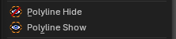
Polyline Hide
Calls a poly line tool which hides the vertices at the one side away after you draw and confirm the polyline shape.

Polyline Show
Calls a poly line tool that allows you to reveal hidden mesh parts after you draw and confirm the polyline shape.

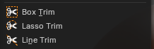
Box Trim
Calls a rectangle tool that cuts away mesh parts, dependent of the view.

Lasso Trim
Calls a rectangle tool that cuts away mesh parts, dependent of the view.

Line Trim
Calls a line tool that cuts away mesh parts based on ab underside of a line that you can draw from the first click to a second click. The line will show a gradient, any part of the mesh on that side of the gradient will be booleaned.

Line Project
Calls a rectangle tool that cuts away mesh parts, dependant of the view.

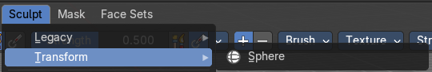
Transform submenu

Sphere
Adds a mesh filter that casts the mesh to a sphere shape.
Activate the tool, click at the mesh, and adjust the sphere shape in the last operator panel.

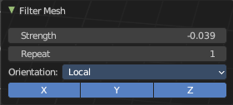
Last operator Filter Mesh

Strength
The strength of the sphere casting

Repeat
How often to repeat the casting.

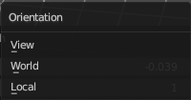
Orientation
The orientation of the tool.

Axis
Which axis to affect.

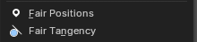
Fair Positions
Edits the current active face set.
Creates a smooth as possible geometry patch from the face set, miniming changes in vertex positions.

Fair Tangency
Edits the current active face set.
Creates a smooth as possible geometry patch from the face set, miniming changes in vertex tangents.

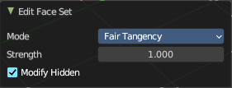
Last Operator Edit Face Sets

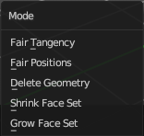
Mode
The face set modification mode.

Strength
How strong the operation should be applied.

Modify Hidden
Also modify hidden geometry.

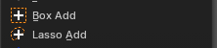
Box Add
Calls a rectangle tool that adds mesh parts, dependant of the view.

Lasso Add
Calls a rectangle tool that adds mesh parts, dependant of the view.

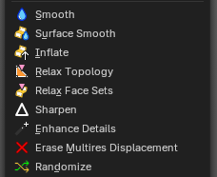
Smooth
An act-once operator that smoothens the object.

Surface Smooth
An act-once operator that smoothens the surface while preserving volume.

Inflate
An act-once operator that inflates the surface volume.

Relax Topology
An act-once operator that relaxes the topology of the mesh.

Relax Face Sets
An act-once operator that relaxes the face sets and smooths them out.

Sharpen
An act-once operator that sharpens the face sets.

Enhance Details
An act-once operator that enhances the details of the mesh.

Erase Multires Displacement
An act-once operator that erases multiresolution displacement.

Randomize
An act-once operator that randomizes the mesh topology.

Last operator Filter Mesh

Strength
The strength of the sphere casting

Repeat
How often to repeat the casting.

Orientation
The orientation of the tool.

Axis
Which axis to affect.

Subdivide submenu
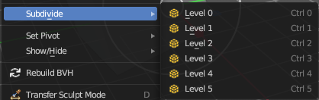
Subdivide is a menu where you can quickly set the subdivision level of the selection. What it does is to add a SDS modifier in the Properties Editor if required. And set the SDS level to the needed value. Crtrl 0 sets SDS to level 0. Ctrl 1 sets SDS level to 1 , and so on.
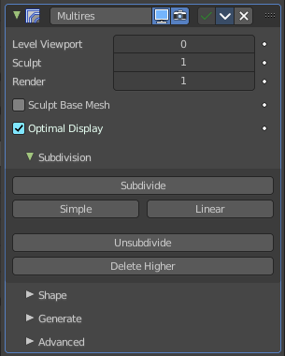
SDS happens at Object mode level. Even when you apply it in the Sculpt Mode! And it happens at the whole object. The sculpting though still happens at the base mesh.

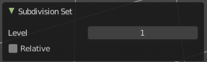
Last Operator Subdivision Set

Level
Adjust the SDS level.

Relative
Applies the Subsurf Level as an offset relative to the current level.

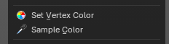
Sample Color
Samples the vertex color attribute of the active vertex.

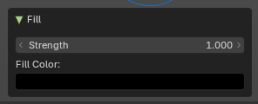
Set Vertex Color
Flood fills the vertex colors with the current vertex color value. Applies a vertex color to the selected or affected geometry during sculpting. Useful for painting, shading, or marking areas directly on the mesh without switching to Vertex Paint mode.

Last operator Fill

Strength
Controls the intensity of the color application.

Fill Color
Defines the color applied to vertices.

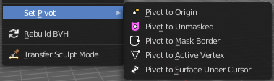
Set Pivot
Sets the pivot to the chosen location. The menu items should be self explaining. So we don't repeat them here.

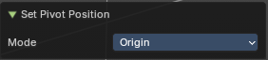
Last operator Set Pivot Position

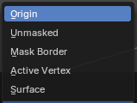
Mode
How to set the pivot to.

Show / Hide submenu

Toggle Visibility
Toggles the visibility of face sets.

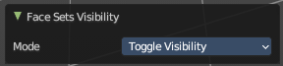
Last operator Face Sets Visibility

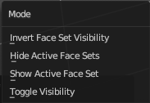
Mode
The show hide modes for face sets.

Hide active Face Sets
Makes the active face sets invisible.

Last operator Face Sets Visibility

Mode
The show hide modes for face sets.

Show All
Makes all invisible mesh parts visible again.

Invert Visible
Toggles the visibility of the selected face sets.

Last operator Face Sets Visibility

Mode
The show hide modes for face sets.

Hide Masked
Hides the masked mesh part.

Rebuild BVH
Recalculate the sculpt BVH to improve performance.


Transfer Sculpt Mode
Switch to another object in Sculpt mode. The tool calls an object picker with which you can choose the object that you want to switch to.
There is also a hardcoded hotkey D, which works directly. Hover with the mouse over the object, and press D

